Workbook Companion to
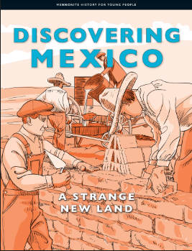

This workbook is meant as a companion piece to the text, Mennonite History for Young People Volume 2 - Discovering Mexico: A Strange New Land. By using a culturally relevant text with our Mennonite students it is hoped that the learners will be more engaged as they see themselves and their culture as respected and valued, reflected within both the historical context and today.
The intent of this workbook is to connect with the Ontario curriculum for Language Arts and Social Studies. The Mennonite History books, and by extension this workbook, meet the goals of social studies as described in the introduction of the Ontario Social Studies Curriculum by helping learners to develop a sense of self, time and place. The questions within connect with the strands of the grades 1-6 Social Studies Curriculum of A. Heritage and Identity and B. People and Environments as well as the grade 7 Geography strand Natural Resources Around the World and the grade 8 History strand Creating Canada and Geography strand Global Settlement. The text also connects wonderfully to the Language Arts Curriculum as it is presented using a range of text forms (diary entries, vignettes, informational text and graphics) and provides opportunities for vocabulary development within a supported context. Because the text is written at a grade 6 reading level, the specific expectations covered in the grade 6 Social Studies and Language Arts Curriculum can be found on page 2.
The skills developed within this workbook include:
- Using contextual clues to identify the meaning of new words
- Using text features to further understanding
- Using graphic organizers to develop ideas and sort information
- Evaluating primary resources to develop a more thorough understanding of historical events and experiences
- Looking at different points of view
- Retelling and summarizing
- Reading and understanding maps
- Framing their own knowledge, experience and culture within a historical context

Specific Curricular Connections
Ontario Social Studies Curriculum
A1.1 explain how various features that characterize a community can contribute to the identity and image of a country
A1.2 evaluate some of the contributions that various ethnic and/or religious groups have made to Canadian identity
A2.2 gather and organize information from a variety of primary and secondary sources using various technologies
A2.3 analyse and construct print and digital maps as part of their investigations into different perspectives on the historical and/or contemporary experience of communities in Canada
A2.4 interpret and analyse information and evidence relevant to their investigations, using a variety of tools
A3.1 identify the main reasons why different peoples came to Canada
A3.3 identify various types of communities that have contributed to the development of Canada
A3.7 describe significant changes within their own community in Canada
Language Arts Reading
1.1 read a wide variety of texts from diverse cultures, including literary texts
1.3 identify a variety of reading comprehension strategies and use them appropriately before, during, and after reading to understand increasingly complex texts
1.4 demonstrate understanding of increasingly complex texts by summarizing and explaining important ideas and citing relevant supporting details
1.5 develop interpretations about texts using stated and implied ideas to support their interpretations
1.8 make judgements and draw conclusions about ideas in texts and cite stated or implied evidence from the text to support their views
2.3 identify a variety of text features and explain how they help readers understand texts
3.2 predict the meaning of and rapidly solve unfamiliar words using different types of cues
Language Arts Writing
1.5 identify and order main ideas and supporting details and group them into units that could be used to develop a structured, multi-paragraph piece of writing, using a variety of strategies
2.1 write longer and more complex texts using a wide range of forms
Graphic organizers were made adapted from https://teachertools.studiesweekly.com/graphic-organizers/ and made using Canva.
Chapter One: Meeting
Vocabulary Building
Reading is one of the best ways to learn new words. When we find new words in text, it can be helpful to guess their meaning from the context, or the other words, of the sentence. In this text the meaning of the bolded words can often be found by looking to the context clues right after it. If you are still not sure what the word means, you can use the glossary in the back of the text (starting on page 76). A glossary has key words listed in alphabetical order with their definitions. Complete this chart of important vocabulary as you read the text. The first line is completed for you.
Word | I know this word./This is a new word for me. | How it appears in the text | What I think the word means
armed | This is a new word for me. | “In Juarez, a group of soldiers – well armed with rifles and revolvers on their hips – got on the train.” (pg. 2) | had rifles and revolvers
prairies |  | “The Mennonites came from the flat prairies of Canada.” (pg. 2)
light-skinned |  | “A crowd of Mexicans surrounded the light-skinned, white strangers as they stepped off the train.” (pg. 3)
peddlers |  | “Some of these peddlers, selling their goods, cheated the Mennonites.” (pg. 3)
were at home |  | “Mennonites learned how to live in their new home from the people who were at home, who lived there.” (pg. 3)
represented |  | “He represented, spoke for the government of Germany in Mexico.” (pg. 4)
negotiate |  | “Many times he helped them negotiate, discuss things with the Mexican government.” (pg. 4)
separate |  | “Mennonites from Canada were a separate people.” (pg. 5)
prosper |  | “If the colonies were to prosper, do well, they would have to get to know the people in whose country they lived.” (pg. 5)
cultivated |  | “They cultivated land and grew food on it.” (pg. 7)

Pick 3 words that were new to you and write a sentence using the word to show your understanding of the word’s meaning.

Comprehension Questions
- When reporters are covering a news story, they often talk about the 5 Ws (who, what, where, when and why). These are the key questions that need to be answered to understand an event. Fill in the graphic organizer (chart) below as if you were a reporter covering the first meeting between the Mennonite delegates and the Mexican president, Alvaro Obregón, in Mexico City.
- Who was Walter Schmiedhaus? Why was it helpful for the Mennonites to have him as a friend in Chihuahua State?

- What did President Alvaro Obregón promise the Mennonites in their Privilegium?

- A map is a drawing of a place that gives information about that place. It might show things that are visible there such as lakes and roads or it might show things that we can’t see in person such as borders between towns. What does the map on page 6 show?
Chapter Two: Getting to Know the Land
Vocabulary Building
Complete this chart of important vocabulary as you read this chapter.
Word | I know this word./This is a new word for me. | How it appears in the text | What I think the word means
gulped |  | “First he gulped down, drank a dipper of water.” (pg. 10)
gritty |  | “But here the air was gritty, rough.” (pg. 10)
pews |  | “After the sermon, the people kneeled on the floor by the wooden boards that were their first pews, church benches.” (pg. 11)
reassured |  | “They needed to be reassured, comforted.” (pg. 11)
climate |  | “He could see how hard it was for them to get used to the climate, weather.” (pg. 11)
the heavens |  | “Regarding water, the heavens, skies are extraordinarily frugal, very stingy.” (pg. 12)
extraordinarily frugal |  | “Regarding water, the heavens, skies are extraordinarily frugal, very stingy.” (pg. 12)
towering |  | “Where else could one see such towering, high clouds, rimmed, bordered with golden sunshine?” (pg. 12)
rimmed |  | “Where else could one see such towering, high clouds, rimmed, bordered with golden sunshine?” (pg. 12)
sultry |  | “Was there anything more wonderful than the time after a sultry, hot and humid thunderstorm?” (pg. 13)
meagre |  | “The oats which looked so meagre, small, now grow with astonishing speed.” (pg. 13)
bellies |  | “They stand in green prairie grass that reaches up to their bellies, stomachs.” (pg. 13)
treacherous |  | “With it comes treacherous, dangerous winds.” (pg. 13)
plateau |  | “Dry, unstoppable winds blow across the plateau, hills or mountains with flat tops.” (pg. 13)
wind stockings |  | “Wind stockings swirl over the fields.” (pg. 13)
announced |  | “But Pau, there’s no village here!” Abram had announced, said.” (pg. 15)
mortar |  | “Into the wet mortar, mud between the bricks he stuck small red stones in a pretty pattern.” (pg. 14)
tossed |  | “… meanwhile I put two kernels into the other hand and tossed, threw them neatly into the hole.” (pg. 18)

Pick 3 words or phrases that were new to you and write a sentence using the word to show your understanding of the word’s meaning.

Comprehension Questions
- As the Mennonites settled in Mexico, it became clear that the climate (temperature and weather patterns) of Mexico and Canada were very different! As you read chapter 2, fill in the T-chart comparing the two climates. The first line is filled in for you as an example.
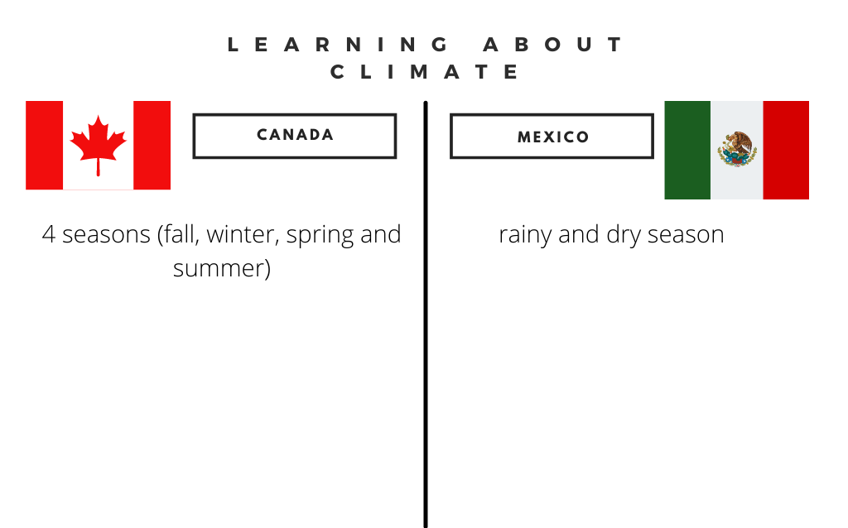

- What does Los Arenales mean in English? Why is this a good name for the city of San Antonio de los Arenales?

- Chapter two includes a beautiful description of northern Mexico written by Walter Schmiedhaus. His use of strong adjectives helps create an image (picture) of the place for the reader. Using his description from pages 12-13, illustrate (draw) a picture of what Northern Mexico looked like in the time of Walter Schmiedhaus in the frame below.
- Read Abram’s Vignette (pages 15-16). How are adobe bricks made?

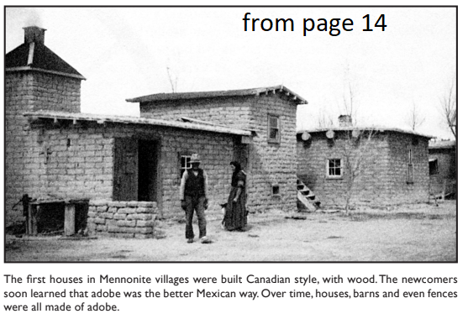
- Why were adobe houses better for the climate of Mexico than the wooden houses the Mennonites were used to building in Canada? (List at least 2 reasons why from pages 16-17.)

- Sarah Wiebe is a great storyteller. Those who were lucky enough to hear her stories learned many interesting things. In her story on pages 17-18, she talks about how her family’s farm did better than many of her neighbours because they learned from the Mexicans. What was the Mexican way of planting corn? How was this different from the traditional Mennonite method?

Chapter Three: Conducting Business
Vocabulary Building
Complete this chart of important vocabulary as you read this chapter.
Word | I know this word./This is a new word for me. | How it appears in the text | What I think the word means
steam-powered locomotives
perked up our ears
dry goods
wares
wobbly
lugged
dashed
colourful scene

Pick 3 words or phrases that were new to you and write a sentence using the word to show your understanding of its meaning.

Comprehension Questions
- In chapter three, we learn that the Mennonite move to Mexico was beneficial (a good thing) for both the Mennonites and Mexicans. What are some of the ways the Mennonite settlements were good for Mexico?

- What do the two photographs on page 23 show? (Hint: In a text, underneath or beside a photograph is a caption. The caption tells what the photograph is showing.)

- Look at the picture on the bottom of page 24. How were village stores at the time different from the stores we shop in now?

Chapter 4: Whose Land?
Vocabulary Building
Complete this chart of important vocabulary as you read this chapter.
Word | I know this word./This is a new word for me. | How it appears in the text | What I think the word means
banded together
revolt
slogan
overthrown
Socialist government
shrewd
revolution
unjust
foreigners
unruly
Tirades
On their behalf
Power of attorney
In good faith
Drainage ditches

Pick 3 of the words and phrases that were new to you and write a sentence using the word/phrase to show your understanding of its meaning.

Comprehension Questions
- Why did the poor people of Mexico fight a revolution from 1910-1920?

- Who lead the revolution in the South? Who lead the revolution in the North?

- From whom did the Mennonites buy their land in Mexico?

- Who were the Agraristas?

- The revolutionary slogan “The land belongs to those who cultivate it!” became a problem for the Mennonites when they moved to settle on the land they had purchased. Why?

- Solving their land problem with the Agraristas took many steps. Fill in the sequencing chart with the steps the Mennonites took in chronological order (the order in which the events happened). The first event is filled in for you.
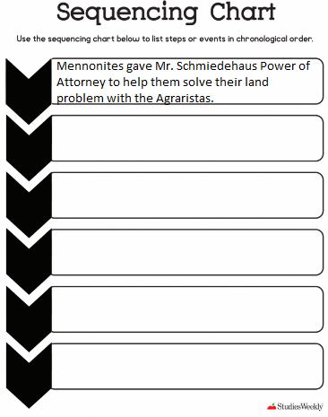
Chapter Five: Good Leaders Make Good Colonies
Vocabulary Building
Complete this chart of important vocabulary as you read this chapter.
Word | I know this word./This is a new word for me. | How it appears in the text | What I think the word means
elected
see them through
self-sufficient
outstanding
resilient
required
negotiator
committed
equal
razor
stubble

Pick 3 words or phrases that were new to you and write a sentence using the word or phrase to show your understanding of its meaning.

Comprehension Questions
- The success of the colonies was largely related to the success of their leadership. In chapter 5 we learn about the leadership in the colonies. Complete the chart below by filling in the roles of the elected leaders (what their job responsibilities were).
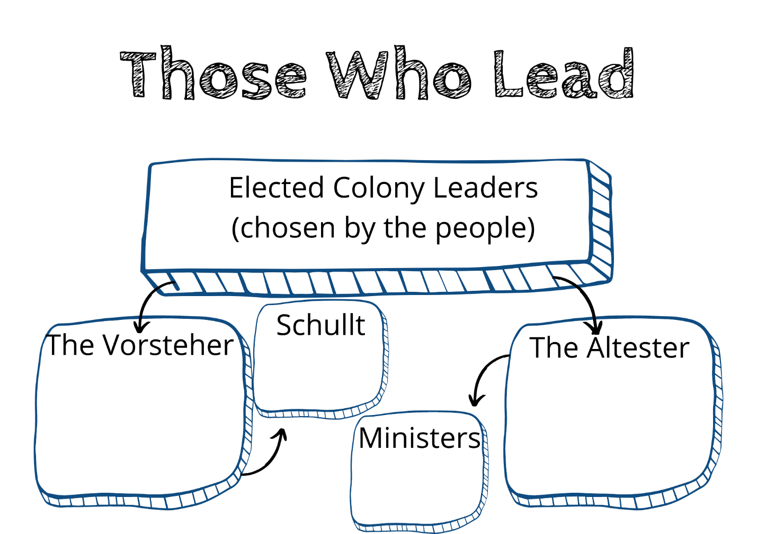

- The Durango Colony was fortunate (lucky) to have an excellent leader in Minister Johan Wall. Read about his life and fill in the chart below.
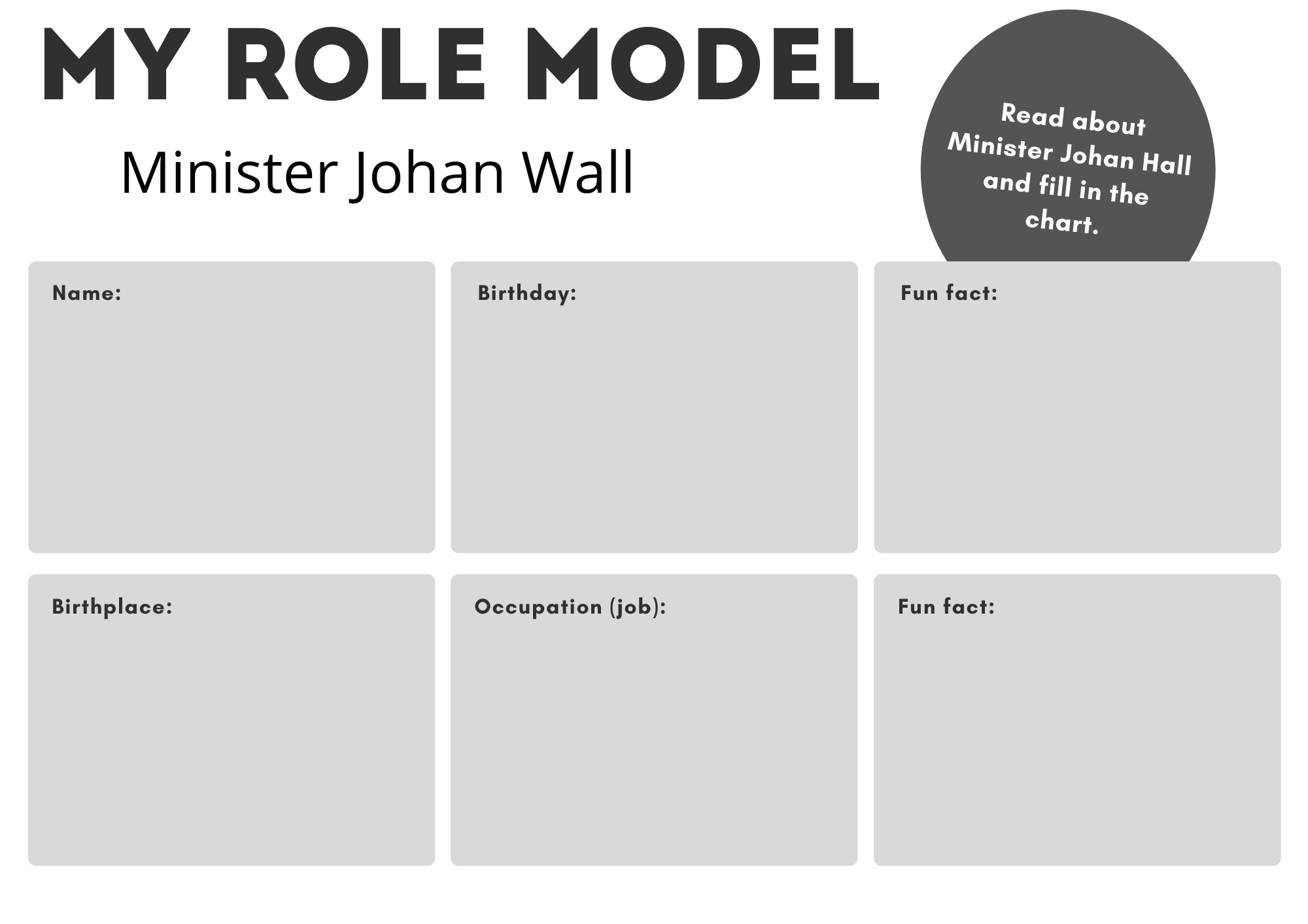
- Having read about the leadership in the colonies, what qualities and characteristics do you think are important to have to be a good leader?
Chapter Six: Trouble Comes to the Colonies
Vocabulary Building
Complete this chart of important vocabulary as you read this chapter.
Word | I know this word./This is a new word for me. | How it appears in the text | What I think the word means
In debt to
hospitality
feed
economic depression
value
uneasy
break off
custom
blazed

Pick 3 words or phrases that are new to you and write a sentence using the word to show your understanding of the word’s meaning.

Comprehension Questions
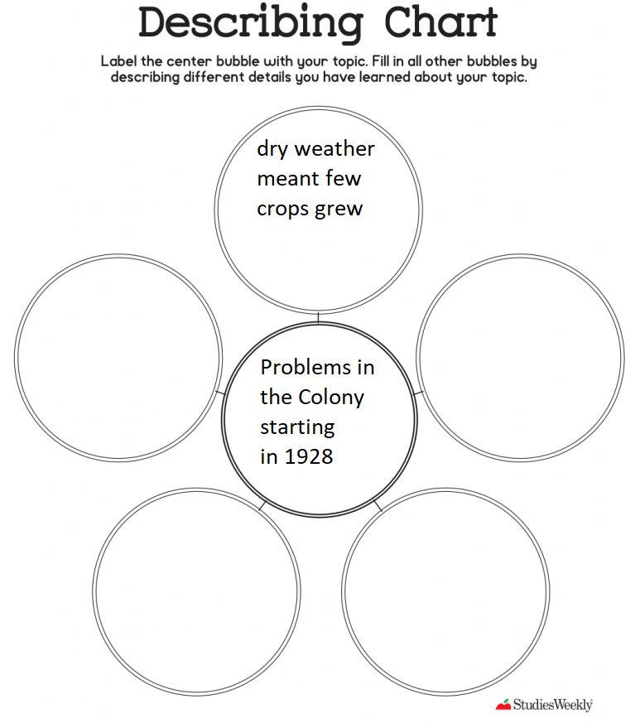
- Starting in 1928, many hardships (problems) affected the colony. Read the chapter and identify 5 problems that the colony was having. Write one in each of the circles surrounding the middle circle below. The top circle is filled in for you as an example.

- In the pink text box on page 58, we learn a bit about what school was like for students in 1936. What are some ways school then was different from your school now? How is it similar?

- On pages 61-63 we learn about Mexican and Mennonite funerals. Describe what a funeral is like in each culture by filling in the t-chart. Write what happens at Abuela Julia’s funeral in the left column and what happens at Grandmother Klassen’s funeral in the right column.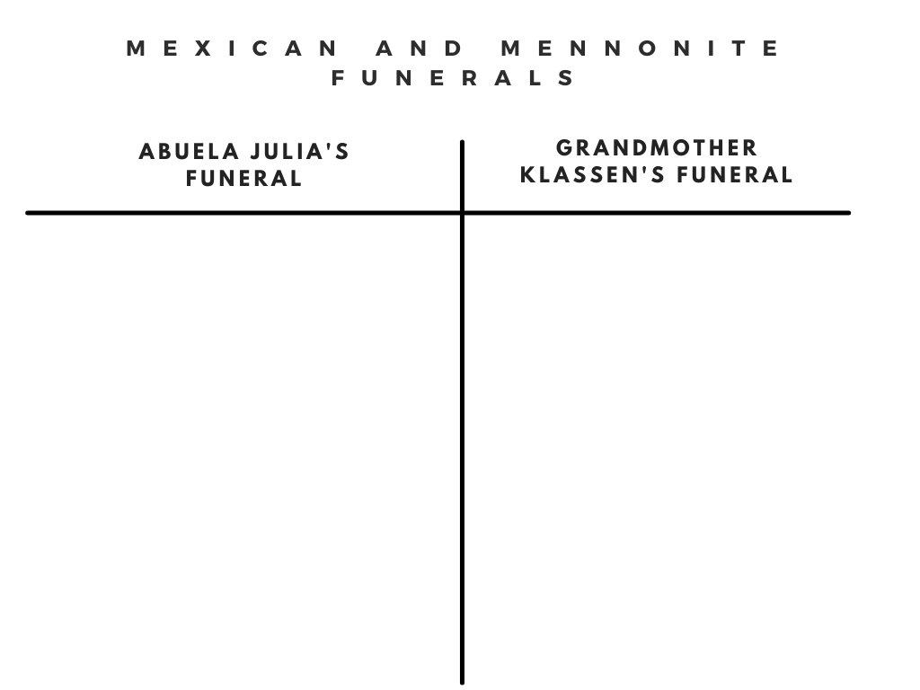

- Share two things you notice (similarities or differences) between the two types of funerals.
Chapter Seven: Courage
Vocabulary Building
Complete this chart of important vocabulary as you read this chapter.
Word | I know this word./This is a new word for me. | How it appears in the text | What I think the word means
seed grains
riled up
flushed
paused
perishing
rebuked
highlights
best effort
were looking up

Pick 3 words or phrases that were new to you and write a sentence using the word to show your understanding of the word’s meaning.

Comprehension Questions
- This chapter begins with the quote, “The farmers here are standing with only one of their feet on their land.” What do you think was meant by this?

- Section 3 of this chapter talks about how history often just tells highlights, the most interesting or important events, but does not talk as much about the day-to-day life of people. While the 1930s were very hard for Mennonites in Mexico (and indeed for people all over the world this time is known as the Great Depression), people were still busy living their lives as best they could. Many people now believe the day-to-day life of people is also interesting - some people even publish their diaries! Diaries give a great glimpse into what a person’s life is like, even if nothing much of interest happens to a person. Write a diary for a day in your life this week. Include as much as you can about what happened to you that day. Use the template on the next page.
Summative Task
Throughout this text, you have learned about how Mennonites made Mexico their home. In the Defining Chart below, fill in how and why Mexico became home for the Mennonites using what you learned in the text. An example from chapter 7, that children had been born there has been filled in to show you what to do. You can complete the chart using a combination of words and pictures.
