Workbook Companion to
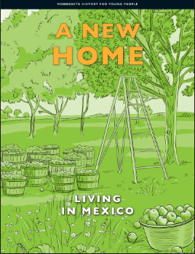

This workbook is meant as a companion piece to the text, Mennonite History for Young People Volume 3 – A New Home: Living in Mexico. By using a culturally relevant text with our Mennonite students it is hoped that the learners will be more engaged as they see themselves and their culture as respected and valued, reflected within both the historical context and today.
The intent of this workbook is to connect with the Ontario curriculum for Language Arts and Social Studies. The Mennonite History books, and by extension this workbook, meet the goals of social studies as described in the introduction of the Ontario Social Studies Curriculum by helping learners to develop a sense of self, time and place. The questions within connect with the strands of the grades 1-6 Social Studies Curriculum of A. Heritage and Identity and B. People and Environments as well as the grade 7 Geography strand Natural Resources Around the World and the grade 8 History strand Creating Canada and Geography strand Global Settlement. The text also connects wonderfully to the Language Arts Curriculum as it is presented using a range of text forms (diary entries, vignettes, informational text and graphics) and provides opportunities for vocabulary development within a supported context. Because the text is written at a grade 6 reading level, the specific expectations covered in the grade 6 Social Studies and Language Arts Curriculum can be found on page 2.
The skills developed within this workbook include:
- Using contextual clues to identify the meaning of new words
- Using text features to further understanding
- Using graphic organizers to develop ideas and sort information
- Evaluating primary resources to develop a more thorough understanding of historical events and experiences
- Looking at different points of view
- Retelling and summarizing
- Reading and understanding maps
- Framing their own knowledge, experience and culture within a historical context

Specific Curricular Connections
Ontario Social Studies Curriculum
A1.1 explain how various features that characterize a community can contribute to the identity and image of a country
A1.2 evaluate some of the contributions that various ethnic and/or religious groups have made to Canadian identity
A2.2 gather and organize information from a variety of primary and secondary sources using various technologies
A2.3 analyse and construct print and digital maps as part of their investigations into different perspectives on the historical and/or contemporary experience of communities in Canada
A2.4 interpret and analyse information and evidence relevant to their investigations, using a variety of tools
A3.1 identify the main reasons why different peoples came to Canada
A3.3 identify various types of communities that have contributed to the development of Canada
A3.7 describe significant changes within their own community in Canada
Language Arts Reading
1.1 read a wide variety of texts from diverse cultures, including literary texts
1.3 identify a variety of reading comprehension strategies and use them appropriately before, during, and after reading to understand increasingly complex texts
1.4 demonstrate understanding of increasingly complex texts by summarizing and explaining important ideas and citing relevant supporting details
1.5 develop interpretations about texts using stated and implied ideas to support their interpretations
1.8 make judgements and draw conclusions about ideas in texts and cite stated or implied evidence from the text to support their views
2.3 identify a variety of text features and explain how they help readers understand texts
3.2 predict the meaning of and rapidly solve unfamiliar words using different types of cues
Language Arts Writing
1.5 identify and order main ideas and supporting details and group them into units that could be used to develop a structured, multi-paragraph piece of writing, using a variety of strategies
2.1 write longer and more complex texts using a wide range of forms
Graphic organizers were made adapted from https://teachertools.studiesweekly.com/graphic-organizers/ and made using Canva.
Introduction
Vocabulary Building
Reading is one of the best ways to learn new words. When we find new words in text, it can be helpful to guess their meaning from the context, or the other words, of the sentence. In this text the meaning of the bolded words can often be found by looking to the context clues right after it. If you are still not sure what the word means, you can use the glossary in the back of the text (starting on page 76). A glossary has key words listed in alphabetical order with their definitions. Complete this chart of important vocabulary as you read the text. The first line is completed for you.
Word | I know this word./This is a new word for me. | How it appears in the text | What I think the word means
descendants | This is a new word for me. | “It is also about their descendants, or their children and grandchildren.” (pg. ix) | One’s children and grandchildren
forebears

Pick one word that is new to you and write a sentence using the word to show your understanding of the word’s meaning.

Chapter One: Before You Read the Story
Vocabulary Building
Complete this chart of important vocabulary as you read the text.
Word | I know this word./This is a new word for me. | How it appears in the text | What I think the word means
established

Use the word established in a sentence to show your understanding of the word’s meaning.

Comprehension Questions
- In the 1920s how many Mennonites moved from Canada to Mexico?

- In Chapter one, it says “the Mennonites never really stopped pioneering.” What does it mean to pioneer?

- What language do the Mennonites speak in their daily lives? What language is it closely related to?

- This text features the stories of two people, David Peters and Sarah Wiebe Fast. Read their mini-biographies on page 4. Once you have read both, pick one to fill in the chart below.
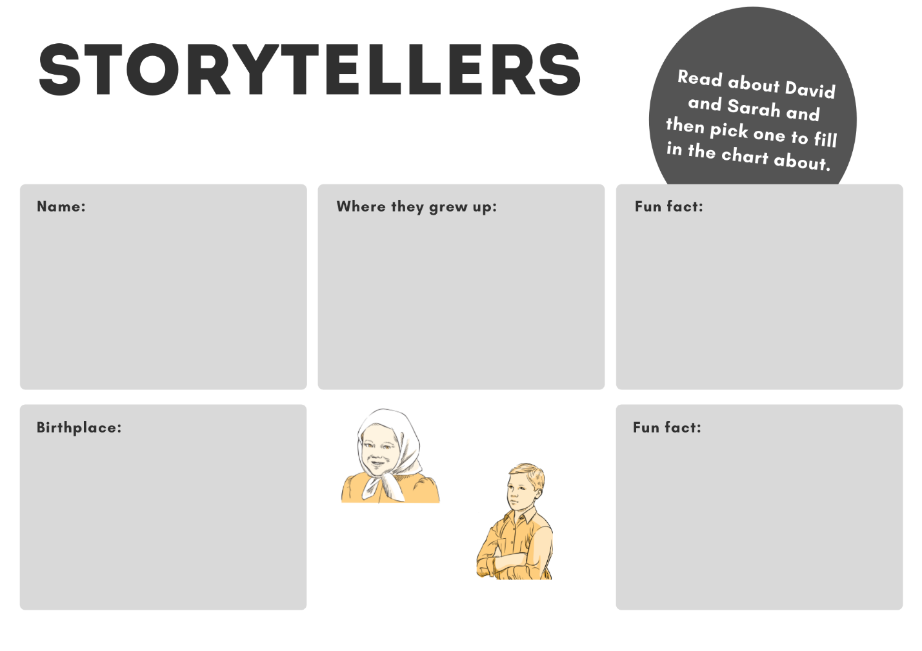
Chapter Two: Growing up in Mexico
Vocabulary Building
Complete this chart of important vocabulary as you read this chapter. The first line is completed for you.
Word | I know this word./This is a new word for me. | How it appears in the text | What I think the word means
recited | This is a new word for me. | “Then each group recited, or read out loud.” | Say from memory
inherited
penmanship
embellished
tackle
implements
mortified
Frugal

Pick 3 words or phrases that were new to you and write a sentence using the word to show your understanding of the word’s meaning.

Comprehension Questions
- A big reason for the move to Mexico was freedom of education, the right for Mennonites to have their own schools with their own curriculum. School was very important, and children had fun there while they learned. Read section 1, What Children Learned in School, and then fill in the describing chart with the subjects they studied. The first bubble is filled in for you as an example.
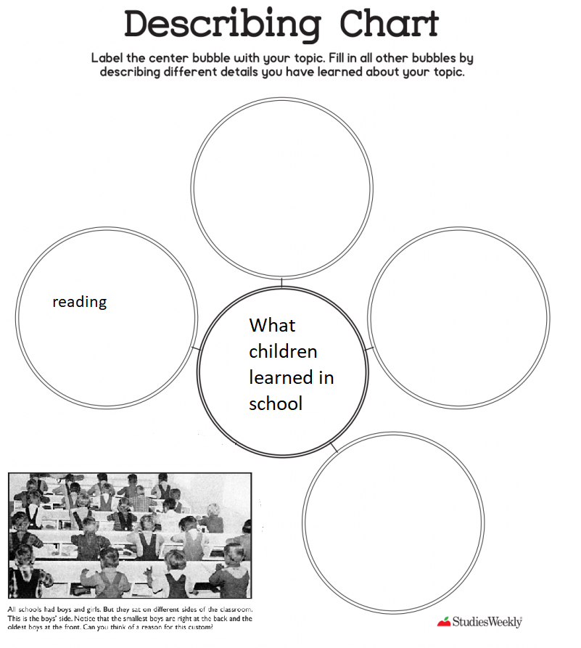
- Margaret talks about her favourite game to play at recess, Jriepa (wood tag). How do you play Jriepa? Does it remind you of any games you like to play?

- The photograph on page 9 shows what a classroom looked like. The caption (text underneath a picture that explains what the picture is showing) says “All schools had boys and girls. But they sat on different sides of the classroom. This is the boy’s side. Notice that the smallest boys are right at the back and the oldest boys at the front. Can you think of a reason for this custom?” Write 2-3 sentences explaining why you think the seating arrangements had the oldest at the front and the youngest at the back.

- In this chapter we also learn about some of the chores children had in the colony: laundry, dishes, sweeping floors and dusting furniture, gardening, milking cows, harnessing and unharnessing horses to buggies and wagons, planting and harvesting, and sewing. Using the t-chart below, compare the chores you do for your family with those of the children in the old colony. Your chores might be quite different or very similar.
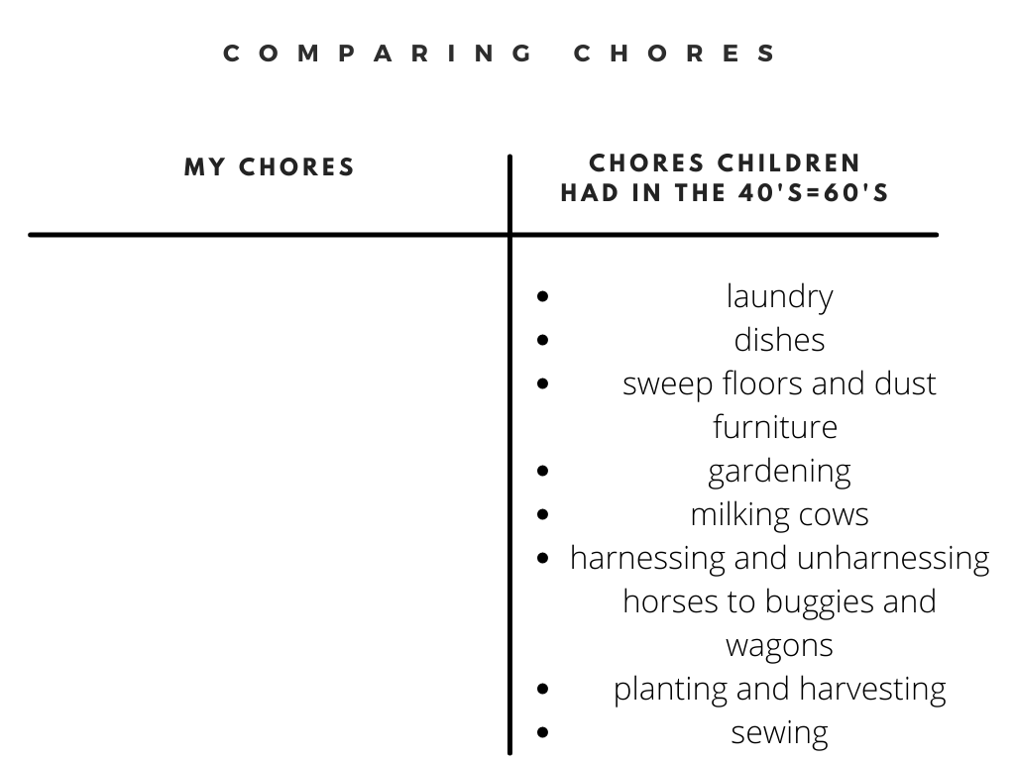

Chapter Three: Children Play and Then Grow Up
Vocabulary Building
Complete this chart of important vocabulary as you read this chapter.
Word | I know this word./This is a new word for me. | How it appears in the text | What I think the word means
Miniature

Use the word miniature in a sentence to show your understanding of its meaning.

Comprehension Questions
- Who is Nätklos?

- In David’s Tale, we learn a bit about the excitement Christmas brought for the children. Their Christmas presents were often homemade and inexpensive but that made them no less special. David remembers the best Christmas present he ever received – a bicycle! Write 2-3 sentences about the best present you have received.

- At what age were the children considered grown and started doing adult work?

- This chapter ends with some stories of when children felt grown up on pages 30-31. The Ws (Who, what, where, when and why) are important questions to ask in understanding an event. Pick either Esther, Helen, Susie or Mary’s story to fill in the chart “Know your Ws!”.

- When do you think you will feel grown up? Or if you do feel grown up, when did you first feel that way?
Chapter 4: Farmers Grow Up
Vocabulary Building
Complete this chart of important vocabulary as you read this chapter.
Word | I know this word./This is a new word for me. | How it appears in the text | What I think the word means
sprout
machete
succulent
green fodder
husk
tedious
vat
source of income
uniform
texture

Pick 3 of the words and phrases that were new to you and write a sentence using the word/phrase to show your understanding of its meaning.

Comprehension Questions
- When the Mennonites moved to Mexico from Canada, they could no longer depend on their skills to grow wheat as wheat was not suitable (didn’t grow well) in Mexico’s climate. Luckily the Mennonites adapted and developed good ways of earning a living. Read page 34 and use what you learn to fill in the Describing chart on the next page. The first bubble is filled in for you as an example.
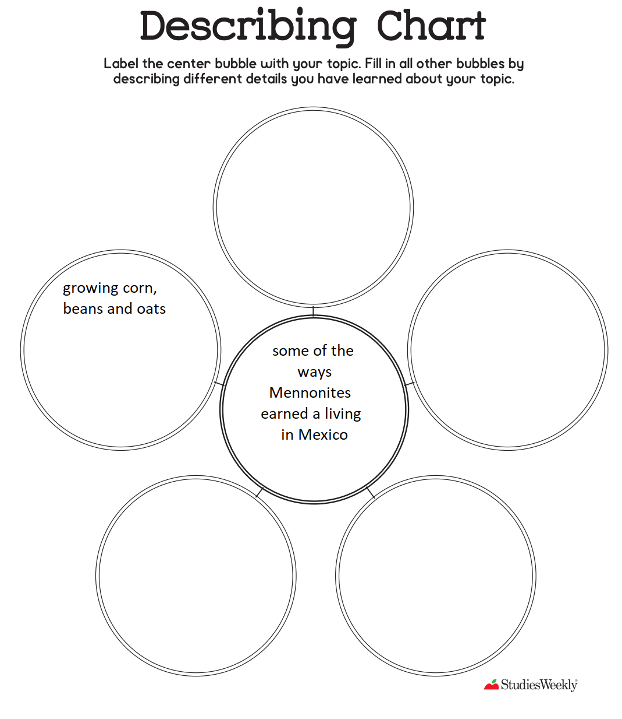

- Corn was one of the new plants that Mennonites learned how to grow. They learned how from the Tarahumara. Describe the steps taken to grow corn in the traditional Tarahumara way in the sequencing chart. The first row is completed for you as an example.
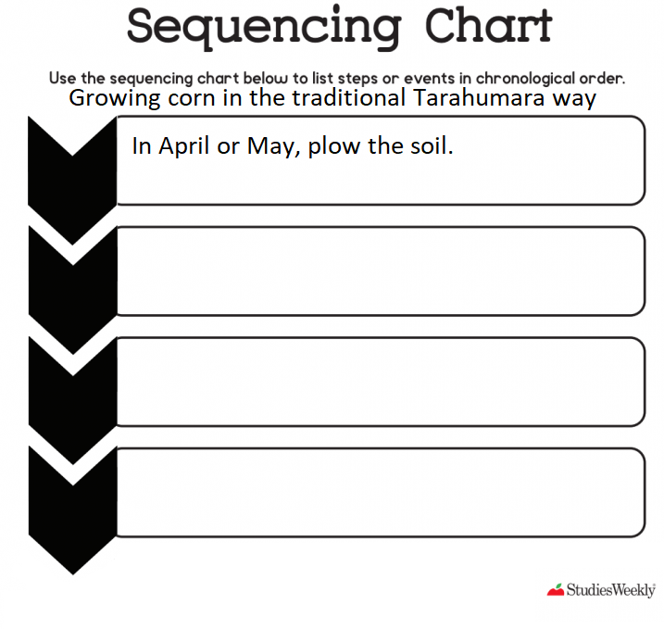
- In Mennonite colonies, whose job was it to pick corn?

- Why was selling their corn a challenge for the Mennonites?

- In what year did the Mennonites in Durango start making cheese? Why was making cheese important?

- In Mennonite colonies nothing goes to waste. What is sour milk be used for?

Chapter Five: Farmers and Gardeners
Vocabulary Building
Complete this chart of important vocabulary as you read this chapter.
Word | I know this word./This is a new word for me. | How it appears in the text | What I think the word means
prune
optimistically
enterprising
attitude
economic depression
crop

Pick 3 words or phrases that were new to you and write a sentence using the word or phrase to show your understanding of its meaning.

Comprehension Questions
- Apples are delicious but starting an orchard is very hard work! Using the describing chart fill each bubble with one of the reasons on page 44 why growing apples can be risky. The first bubble is filled in for you as an example.
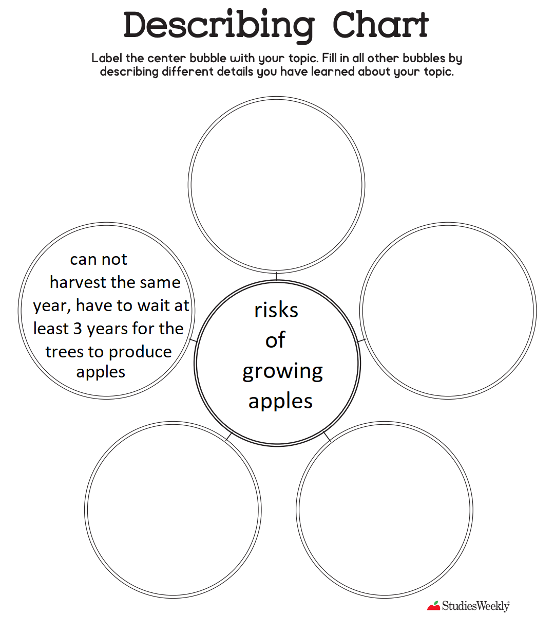
- A big change came to the colonies in 1937. What did the Mennonites switch that year?

- In your own words, explain the 5 reasons why the Mennonites decided to use tractors.
Chapter Six: Inventive Pioneers
Vocabulary Building
Complete this chart of important vocabulary as you read this chapter.
Word | I know this word./This is a new word for me. | How it appears in the text | What I think the word means
precisely
ore
chassis
louvres

Pick 3 words that are new to you and write a sentence using the word to show your understanding of the word’s meaning.

Comprehension Questions
- What does a bean thrasher do?

- What is a hammer mill?

- Using the sequencing chart to explain the process for keeping food cold without a fridge. The first step has been filled in for you as an example.
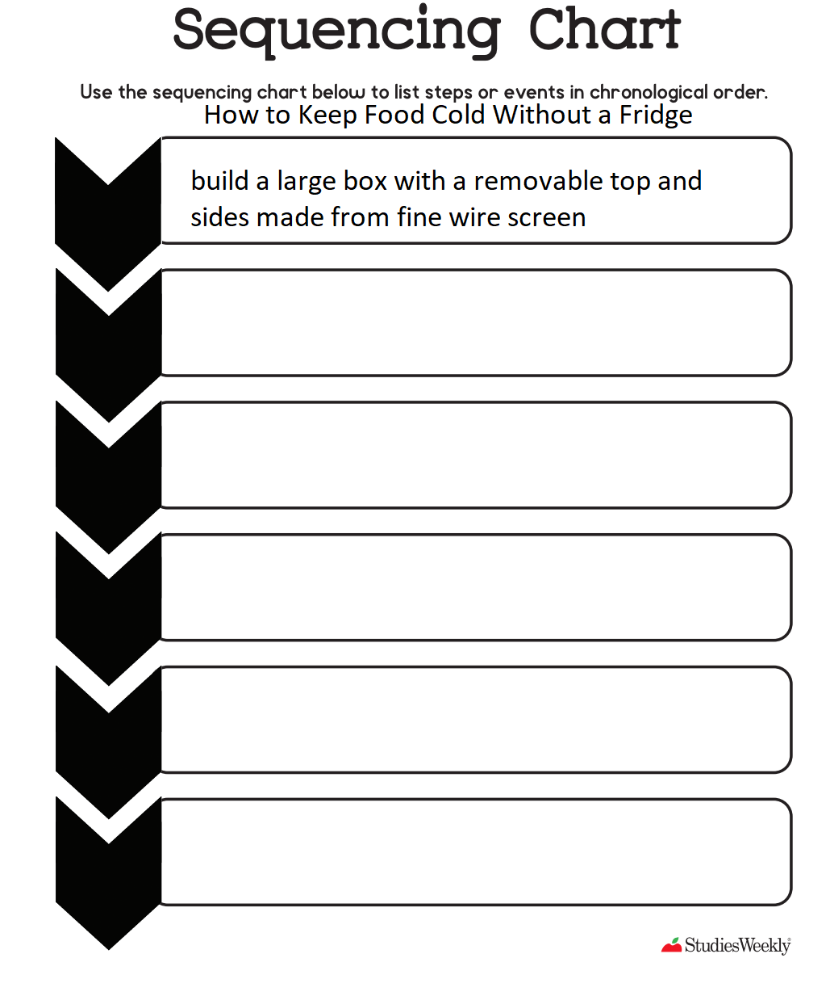
- While they did not drive cars and trucks in the colonies, the Mennonites, as inventive pioneers, did find some great uses for used cars and trucks. Read pages 60-62 and summarize the two problems the Mennonites had and how they used used cars and trucks to solve those problems.
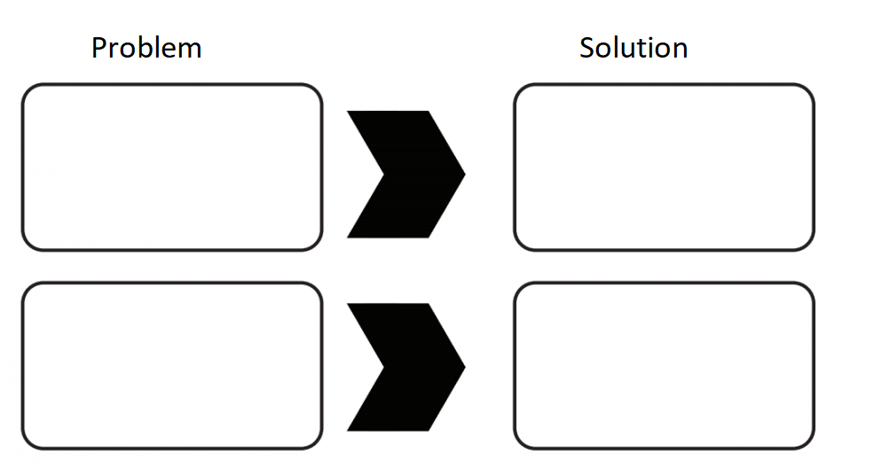

Chapter Seven: Colonies Grow Up
Comprehension Questions
- For Martha, leaving school when she turned 12 was hard. However, she mentions one positive thing about being a grown girl. What could Martha now do during the daytime?

- Who did most villagers go to when they needed advice about numbers?

- David’s story of his father ordering bricks on pages 66-67 is a good example of how important math is in everyday life. What are other examples of how you use math in your everyday life?

- What four colonies make up the Old Colony?

Chapter Eight: The Colonies of Mexico Today
Comprehension Questions
- What was one of the reasons President Plutarco Calles was so impressed with the Chihuahua colonies?

- What does the map on 76-77 show?

- What was special about La Batea?

- How was the Santa Rita Colony founded?

- What is El Capulín known for today?

- Which colony included the former home of Revolutionary leader Pancho Villa?

Summative Task:
As stated in Appendix One (page 81), Mennonite history is closely tied to land. The stories of this text illustrate that connection. Brainstorm (think of) three ways that the text showed how Mennonite history and culture are related to land. Fill your ideas in the graphic organizer on paragraph writing below. Then write a final copy of your paragraph.
