Workbook Companion to
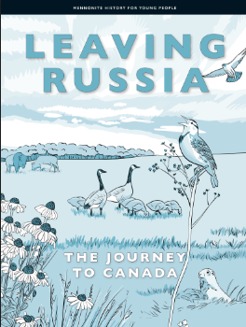

This workbook is meant as a companion piece to the text, Mennonite History for Young People Volume 4 – Leaving Russia: The Journey to Canada. By using a culturally relevant text with our Mennonite students it is hoped that the learners will be more engaged as they see themselves and their culture as respected and valued, reflected within both the historical context and today.
The intent of this workbook is to connect with the Ontario curriculum for Language Arts and Social Studies. The Mennonite History books, and by extension this workbook, meet the goals of social studies as described in the introduction of the Ontario Social Studies Curriculum by helping learners to develop a sense of self, time and place. The questions within connect with the strands of the grades 1-6 Social Studies Curriculum of A. Heritage and Identity and B. People and Environments as well as the grade 7 Geography strand Natural Resources Around the World and the grade 8 History strand Creating Canada and Geography strand Global Settlement. The text also connects wonderfully to the Language Arts Curriculum as it is presented using a range of text forms (diary entries, vignettes, informational text and graphics) and provides opportunities for vocabulary development within a supported context. Because the text is written at a grade 6 reading level, the specific expectations covered in the grade 6 Social Studies and Language Arts Curriculum can be found on page 2.
The skills developed within this workbook include:
- Using contextual clues to identify the meaning of new words
- Using text features to further understanding
- Using graphic organizers to develop ideas and sort information
- Evaluating primary resources to develop a more thorough understanding of historical events and experiences
- Looking at different points of view
- Retelling and summarizing
- Reading and understanding maps
- Framing their own knowledge, experience and culture within a historical context

Specific Curricular Connections
Ontario Social Studies Curriculum
A1.1 explain how various features that characterize a community can contribute to the identity and image of a country
A1.2 evaluate some of the contributions that various ethnic and/or religious groups have made to Canadian identity
A2.2 gather and organize information from a variety of primary and secondary sources using various technologies
A2.3 analyse and construct print and digital maps as part of their investigations into different perspectives on the historical and/or contemporary experience of communities in Canada
A2.4 interpret and analyse information and evidence relevant to their investigations, using a variety of tools
A3.1 identify the main reasons why different peoples came to Canada
A3.3 identify various types of communities that have contributed to the development of Canada
A3.7 describe significant changes within their own community in Canada
Language Arts Reading
1.1 read a wide variety of texts from diverse cultures, including literary texts
1.3 identify a variety of reading comprehension strategies and use them appropriately before, during, and after reading to understand increasingly complex texts
1.4 demonstrate understanding of increasingly complex texts by summarizing and explaining important ideas and citing relevant supporting details
1.5 develop interpretations about texts using stated and implied ideas to support their interpretations
1.8 make judgements and draw conclusions about ideas in texts and cite stated or implied evidence from the text to support their views
2.3 identify a variety of text features and explain how they help readers understand texts
3.2 predict the meaning of and rapidly solve unfamiliar words using different types of cues
Language Arts Writing
1.5 identify and order main ideas and supporting details and group them into units that could be used to develop a structured, multi-paragraph piece of writing, using a variety of strategies
2.1 write longer and more complex texts using a wide range of forms
Graphic organizers were made adapted from https://teachertools.studiesweekly.com/graphic-organizers/ and made using Canva.
Chapter One: A “New” World Across the Atlantic!
Vocabulary Building
Reading is one of the best ways to learn new words. When we find new words in text, it can be helpful to guess their meaning from the context, or the other words, of the sentence. In this text the meaning of the bolded words can often be found by looking to the context clues right after it. If you are still not sure what the word means, you can use the glossary in the back of the text (starting on page 75). A glossary has key words listed in alphabetical order with their definitions. Complete this chart of important vocabulary as you read the text. The first line is completed for you.

Word | I know this word./This is a new word for me. | How it appears in the text | What I think the word means
practice your faith | This is a new word for me. | “You could practice your faith openly.” (pg. 2) | Live the way your faith teaches you
tract
industry
agriculture
progressive
traditions
prospered
independence
pacifists
Czarina
military
executed

Pick 3 words or phrases that were new to you and write a sentence using the word to show your understanding of the word’s meaning.

Comprehension Questions
- What is a colony?

- When did the first Mennonites come to Russia?

- There were 4 Mennonite colonies in Russia at the end of the 1870s when the text starts. Use the graphic organizer below to identify the colonies.
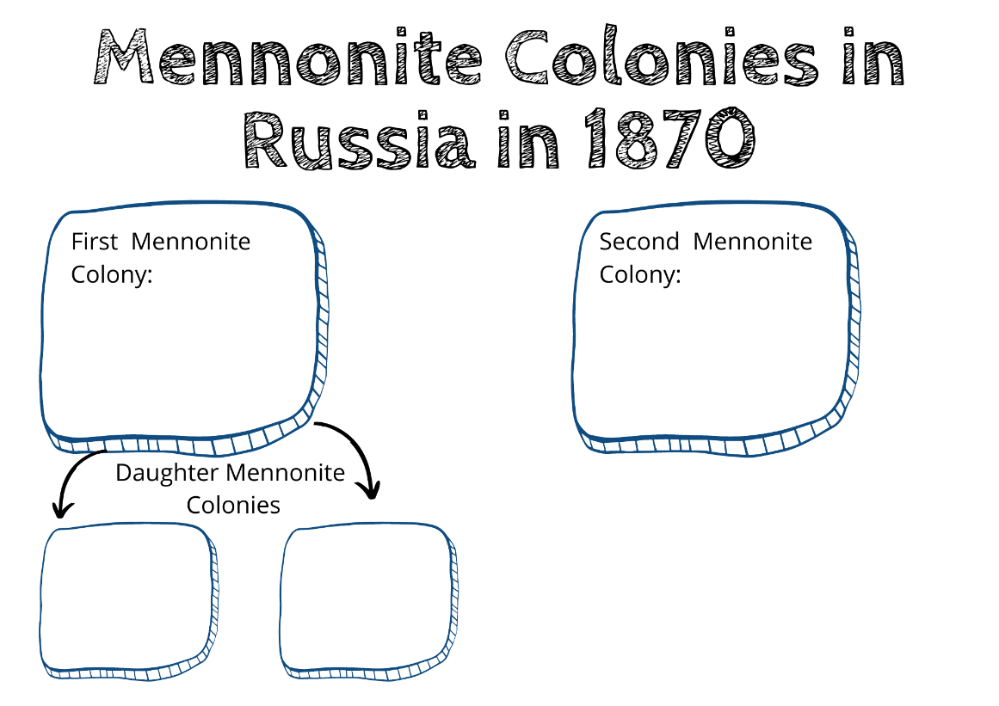
- There were many changes in Russia in the 1800s and the promises made to the Mennonites by Czarina Catherine the Great in 1788 no longer seemed guaranteed. What were some of the concerns the Mennonites had at this time?

- Why did William Hespeler visit Russia?

Chapter Two: Kaunada, Kanada, Canada
Vocabulary Building
Complete this chart of important vocabulary as you read this chapter.
Word | I know this word./This is a new word for me. | How it appears in the text | What I think the word means
nation
claimed
Aboriginal
en bloc
loophole
accumulated
agriculturists
excel
prosperous
dealing in
delegates
on behalf of
ministry
descendants
infuriated mob
displacing a people

Pick 3 words or phrases that were new to you and write a sentence using the word to show your understanding of the word’s meaning.

Comprehension Questions
- In 1872, the Canadian government had settlements on the east (Atlantic) and west (Pacific) coasts of Canada. However, the land in the prairies, in between these settlements, especially around the new Province of Manitoba, was not yet settled by Europeans. Why was this a concern for the government?

- Who was Jacob Y. Shantz?

- Bernhard Warkentin and Jacob Shantz had very different opinions on Manitoba. Fill in the t-chart with their thoughts of Manitoba. Circle the side that you think has the best reasoning. The first line is filled in for you as an example.
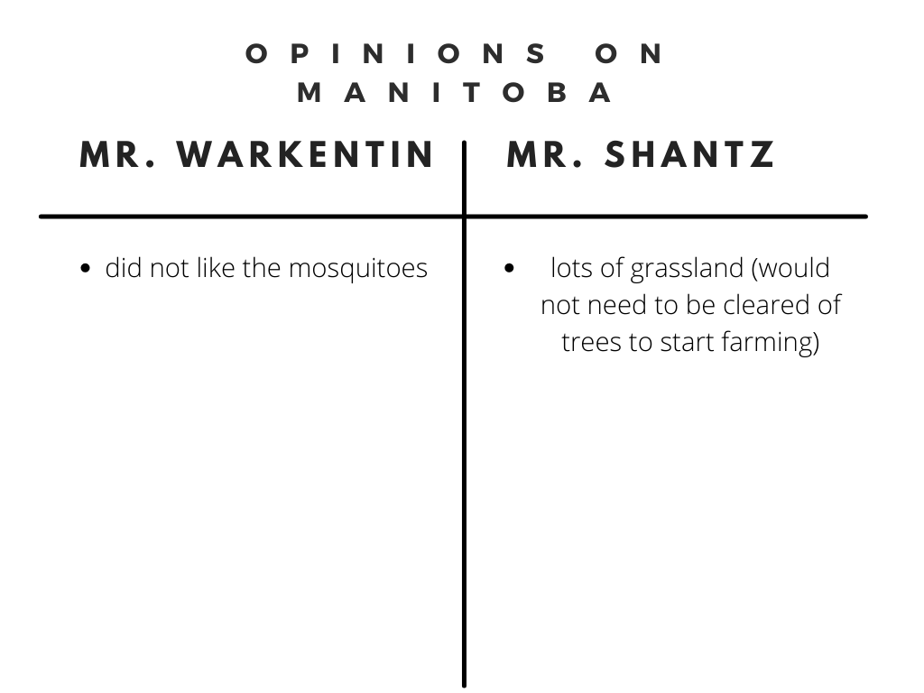

- Why did Russia tell Mr. Hespeler to leave Russia?

- What was the purpose of the delegates' visit to Canada?

- Who are the Métis?

- Canada’s history is one of colonization and stolen land. This means that the English and French that settled in Canada took land from the Indigenous peoples (the people who lived here first) and tried to destroy their people and cultures. The Métis were one of the groups that the Canadian government treated very badly. In 1873, when the Mennonite delegates were visiting Canada, things were very bad between the Métis and the Canadian government. What were some of the wrongs the government had done to the Métis?

***As a step in the reconciliation process with Indigenous peoples of Canada and to affirm their treaty rights, many meetings are now started with a land acknowledgement. Currently, the government of Manitoba does not have an official land acknowledgement, however, Manitoba is Treaty 1 territory and the homeland of the Red River Métis. You can learn more about the first peoples of Canada, their territories and treaties by visiting https://native-land.ca/.

- The advantages to settlers that the Canadian government gave to the Mennonites was very important to their agreeing to move to Canada. Complete the graphic organizer to show your understanding of the promises made and why they were important to the Mennonites. The first line is completed for you as an example.
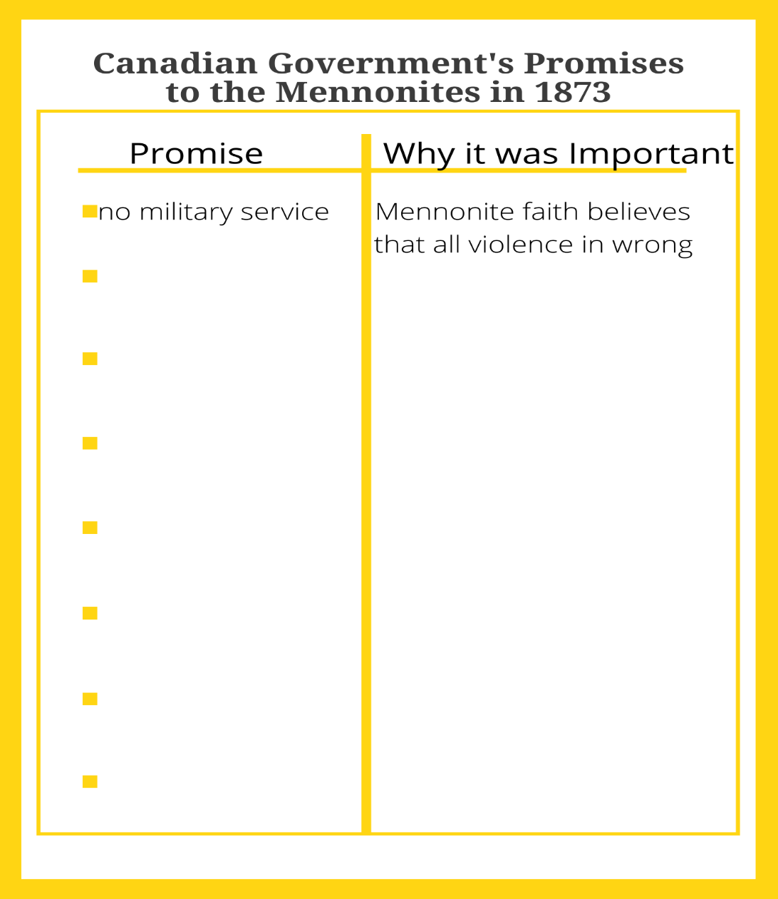

Chapter Three: A New Beginning in Canada
Vocabulary Building
Complete this chart of important vocabulary as you read this chapter.
Word | I know this word./This is a new word for me. | How it appears in the text | What I think the word means
emigrated
autobiography
tossing
disciples
terrifying
anchored
gangplank
penetrating
estate
innumerable

Pick 3 words or phrases that were new to you and write a sentence using the word to show your understanding of the word’s meaning.

Comprehension Questions
- How many people emigrated from the Fürstenland Colony to Canada?

- How much of the Bergthal Colony emigrated to Canada?

- What was the goal of these Mennonites (what did they want) in moving to Canada?

- Why were the winter nights of Manitoba such a good time to tell stories? What is your favourite time to hear or tell stories?

- A map is a drawing of a place that gives information about that place. It might show things that are visible there such as lakes and roads or it might show things that we can’t see in person such as borders between towns. What does the map on page 23 show?

- This chapter ends with the story of Jakob Fehr. Use the retell graphic organizer to retell Jakob and his family’s trip from Russia to Canada in your own words.
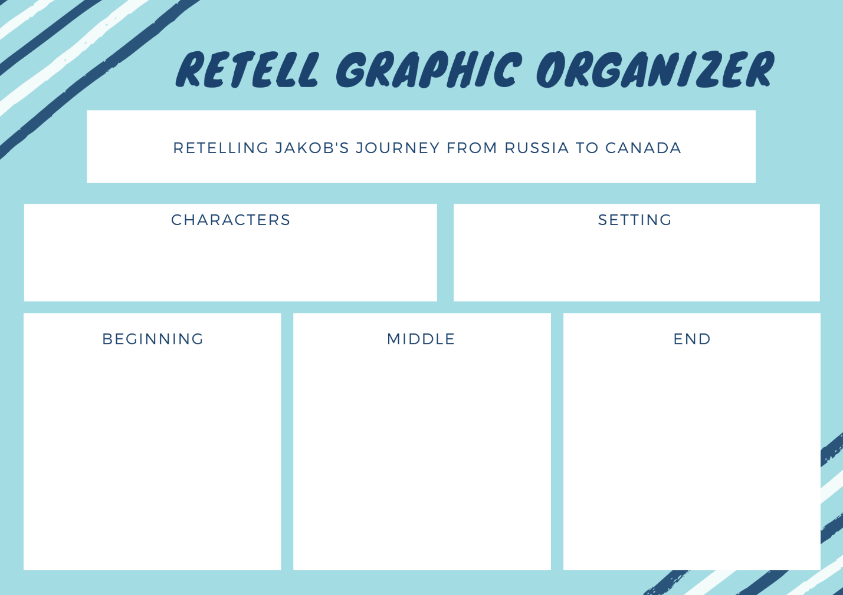

Chapter 4: Dutch Mennonites Meet Swiss Mennonites
Vocabulary Building
Complete this chart of important vocabulary as you read this chapter.
Word | I know this word./This is a new word for me. | How it appears in the text | What I think the word means
hospitality
hospitable
forebears
raw
churning
entrepreneur
enterprise
guarantee the loan
flourished
unassuming

Pick 3 of the words and phrases that were new to you and write a sentence using the word/phrase to show your understanding of its meaning.

Comprehension Questions
- Who welcomed the Russian Mennonites into their homes upon their arrival to Canada?

- What was the purpose of Mr. Schantz’s book, Narrative of a Journey to Manitoba?

- What does the map on page 38 show? What do you notice about how the journey was taken?

- The Manitoba Mennonite settlements flourished as shown by the increases in their population over just 5 years. The settlements grew from 1 400 people in 1874 to 7 000 just 5 years later! What is the difference in population sizes over those 5 years? (Hint: this is a subtraction question.)

- Jakob Shantz was a great man that helped the Manitoba Mennonite settlements considerably. What were some of the qualities that Mr. Shantz had that made him a great friend and community leader?

Chapter Five: Arrival in Manitoba
Vocabulary Building
Complete this chart of important vocabulary as you read this chapter.
Word | I know this word./This is a new word for me. | How it appears in the text | What I think the word means
boarded
scanned
wailing
annoyed
mourning
yearning
surveyed
complicated
elected

Pick 3 words or phrases that were new to you and write a sentence using the word or phrase to show your understanding of its meaning.

Comprehension Questions
- In what year did the first Mennonites from Russia arrive in Manitoba?

- The vignettes on pages 44-45, show the many different feelings Mennonites had about the arrival in Manitoba. Aunsch and Ot are feeling excited to have arrived and are already noticing similarities between the sky of Manitoba and the sky of Russia. Their mother, on the other hand, is feeling sad and tired. She misses her former home and is unsure of what lies ahead of her. Think of a time when you were experiencing a big change (maybe a move, starting school, trying something new for the first time). How did you feel? Can you think of a time when you felt like Aunsch and Ot? What about a time when you felt like Margaret? Share your experiences below.

- The Mennonites had to wait six weeks at the immigration sheds before they could leave for their new land. They used their time well, organizing themselves and preparing. Use the describing chart to show some of the ways they prepared. The first bubble is filled in for you as an example.
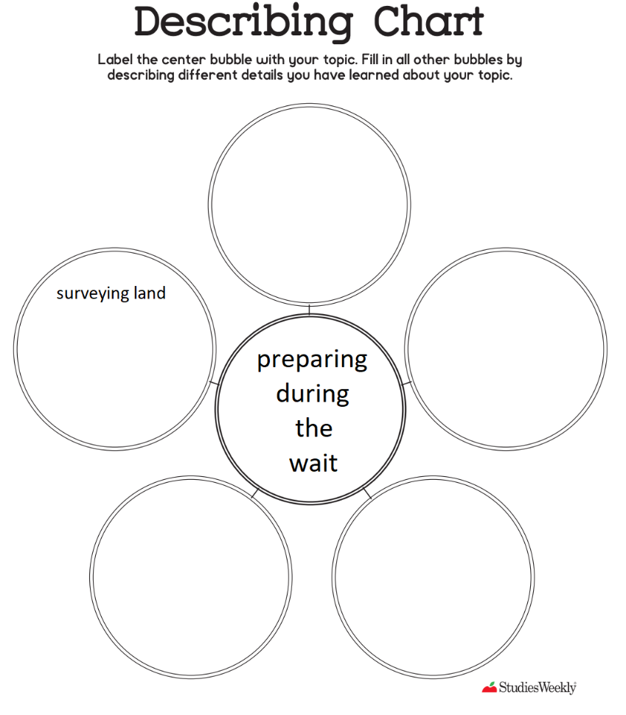

Chapter Six: Getting Settled: Homes and Villages
Vocabulary Building
Complete this chart of important vocabulary as you read this chapter.
Word | I know this word./This is a new word for me. | How it appears in the text | What I think the word means
drawing lots
plod
sods
spars
laths
scythe
thatch
plastered
procession
homesteading
house of worship
heaving

Pick 3 words that are new to you and write a sentence using the word to show your understanding of the word’s meaning.

Comprehension Questions
- How did the families travel to their new land?

- How did Mennonites name their villages in Canada?

- How did the Mennonites honour their friend Jakob Y. Schantz?

- Fill in the Sequencing Chart with the steps to build the Semlin. The first step is filled in for you as an example.
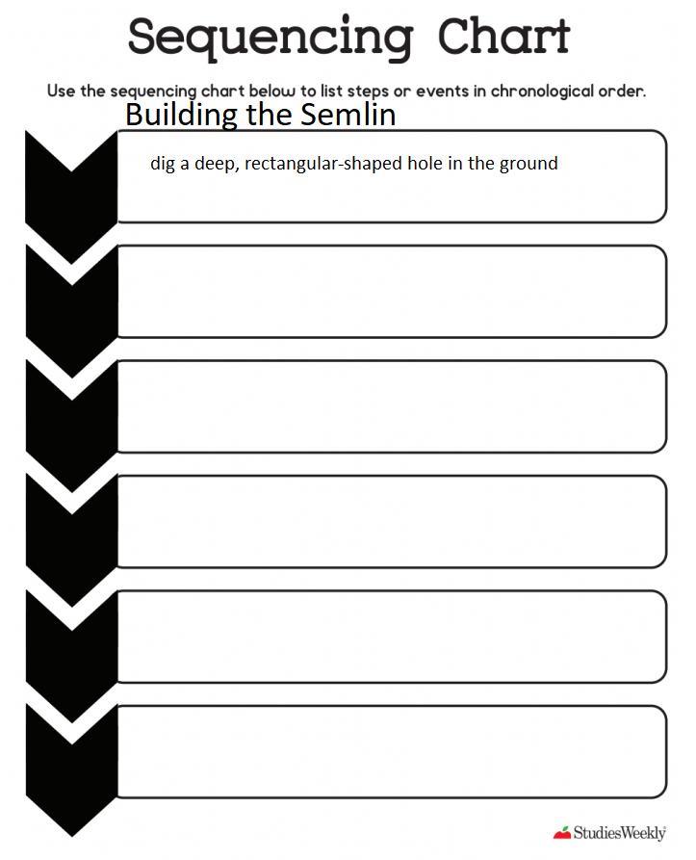

- Explain how the Brettschneideisen (board cutting saw) illustrated on page 58 worked.

- The text ends with the line, “Once they had a church building, the people said that Manitoba had begun to feel a little bit like home.” What is meant by this?

Summative Task
The text of Leaving Russia: The Journey to Canada is largely about home. One of the most important needs for people is a place to belong and to feel at home. Using the graphic organizer on the next page, identify what makes you feel at home in the place or places where you live. These factors may include the people you love, the work you do, your language, your religion and other aspects of your culture that are reflected in where you live. If home is more than one place for you, you can fill in the chart twice, once for each place. Notice what the two places have in common and how they may be different. If you have not yet found a place that feels completely like home for you, write ideas about what such a place might be like. Include one idea in each bubble and fill it in with both words and pictures.
